UNIT 3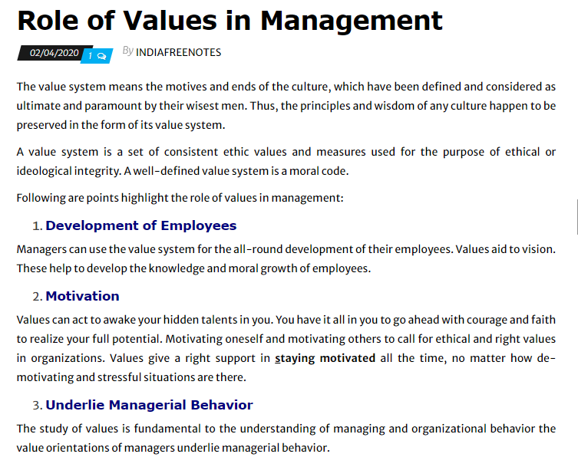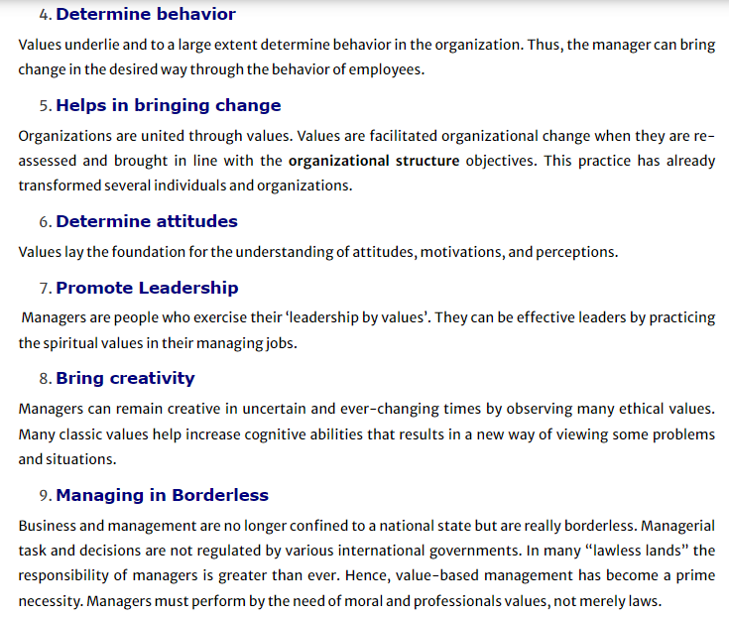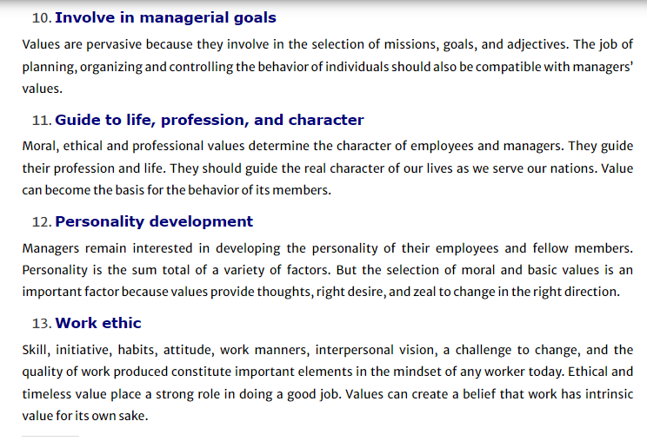
1. Incentives

Definition:
An incentive is a reward or encouragement designed to motivate individuals or groups to perform specific actions or behaviors. It can be in the form of monetary rewards, recognition, or other types of benefits. Incentives play a crucial role in shaping decisions and behavior, especially in fields such as economics, business, and management.

Types of Incentives:
- Monetary Incentives:
  - Examples: Salaries, bonuses, commissions, stock options.
  - Explanation: These incentives are financial rewards aimed at motivating individuals by directly increasing their income. They are commonly used in business environments to improve employee performance and productivity.
- Non-Monetary Incentives:
  - Examples: Praise, awards, recognition, flexible work hours.
  - Explanation: These incentives offer intangible benefits that satisfy psychological and social needs, such as feeling valued or gaining status within a group.
- Direct Incentives:
  - Examples: Performance-based pay, sales commissions.
  - Explanation: These incentives have a clear and direct link between the incentive and the desired behavior, such as an employee earning more money for meeting sales targets.
- Indirect Incentives:
  - Examples: Job security, professional development opportunities.
  - Explanation: These are less tangible incentives but still motivate behavior by creating a favorable environment for the individual. For instance, employees may work harder if they feel their job is secure.

Importance of Incentives:
- Motivation: Incentives drive performance by offering rewards for effort and achievements.
- Retention: Offering appropriate incentives helps retain employees, as people are more likely to stay with organizations that reward them adequately.
- Alignment of Goals: Incentives help align individual or team goals with organizational objectives, ensuring everyone works toward the same outcomes.

Incentive Structures:
- Positive Incentives:
  - Encourage behavior by offering rewards for specific actions or performance.
- Negative Incentives:
  - Discourage unwanted behavior through penalties or consequences (e.g., fines for missing deadlines).

2. Material Incentives

Definition:
Material incentives refer to tangible, physical rewards or benefits that are given to individuals or groups in return for specific actions or performance. These incentives usually have direct economic value and can be used or exchanged for goods or services.

Examples of Material Incentives:
- Cash Rewards:
  - Explanation: Providing direct monetary compensation such as bonuses or salary increases.
  - Impact: Cash is a versatile and highly motivating incentive as it can be used immediately for personal needs.
- Gift Cards and Vouchers:
  - Explanation: Offering vouchers or gift cards for specific products or services.
  - Impact: These are popular in employee recognition programs and offer flexibility, though they may be seen as less valuable than cash.
- Tangible Goods:
  - Examples: Cars, electronic gadgets, appliances, luxury goods.
  - Explanation: Offering physical goods as rewards for exceptional performance.
  - Impact: Tangible goods can have a high emotional and aspirational value, making them effective motivators, especially in sales and marketing fields.
- Health Benefits and Insurance:
  - Explanation: Providing health insurance, gym memberships, or wellness programs as part of employee benefits packages.
  - Impact: These incentives are valuable as they cater to long-term personal well-being and security, offering motivation beyond immediate financial gain.

Benefits of Material Incentives:
- Motivation: Offering material incentives can boost motivation, especially when the incentives are perceived as valuable or desirable.
- Loyalty: Material incentives help foster loyalty by showing employees that their contributions are recognized and rewarded.
- Productivity: Tangible rewards can directly impact productivity as they provide employees with a clear, tangible goal to work towards.

Challenges of Material Incentives:
- Cost: Material incentives often have high financial costs, making them more expensive than non-material incentives.
- Sustainability: Over-reliance on material incentives can lead to diminishing returns, where individuals expect more rewards over time and become less motivated by smaller or repeated rewards.
- Equity: Perceived fairness in the distribution of material incentives is important; if employees feel that rewards are not fairly distributed, it can lead to dissatisfaction.

3. Managing Values through Incentive Mechanisms

Definition:
Managing values through incentive mechanisms involves using rewards or consequences to reinforce certain ethical behaviors, cultural norms, or organizational values. It ensures that individual actions are aligned with the collective principles of the organization.

Key Concepts:
- Value Alignment:
  - Explanation: Using incentives to ensure that employees or members of an organization act in ways that reflect the organization’s core values, such as integrity, innovation, or collaboration.
- Ethical Incentives:
  - Explanation: Incentives designed not only to boost performance but also to promote ethical behavior. For example, rewarding employees who act with integrity or show a commitment to social responsibility.
  - Example: Offering bonuses to managers who prioritize employee well-being alongside financial goals.
- Cultural Reinforcement:
  - Explanation: Incentive systems can reinforce corporate culture by encouraging behaviors that reflect the organization’s identity and mission.
  - Example: A company that values teamwork might provide rewards for collaborative projects rather than individual achievements, promoting a cooperative work environment.

Types of Incentive Mechanisms for Managing Values:
- Performance-Based Incentives:
  - Examples: Bonuses, promotions, recognition for achieving targets.
  - Application: These can be aligned with organizational values by ensuring that performance goals incorporate ethical or cultural considerations (e.g., hitting sales targets ethically, without misleading customers).
- Behavioral Incentives:
  - Examples: Rewarding punctuality, teamwork, customer service excellence.
  - Application: These incentives target specific behaviors that reflect the organization’s values. For instance, a company may offer incentives for employees who actively contribute to corporate social responsibility initiatives.
- Social Recognition:
  - Examples: Employee of the month awards, public recognition for upholding company values.
  - Application: Publicly acknowledging individuals who embody core organizational values can serve as a powerful motivator for others to follow suit.

Importance of Managing Values through Incentives:
- Cultural Cohesion: Incentives that align with core values help reinforce the culture of the organization, ensuring that all members are working towards the same ethical and performance goals.
- Ethical Behavior: By rewarding ethical behavior and penalizing unethical actions, organizations can promote integrity and accountability.
- Sustainability: Organizations that use incentives to align personal goals with company values are more likely to build sustainable growth and a positive reputation.

Challenges:
- Complexity: Managing values through incentives requires balancing tangible performance rewards with the promotion of intangible qualities, like integrity or collaboration.
- Measurement: It can be difficult to objectively measure whether values are being upheld, making it challenging to fairly distribute incentives.
- Unintended Consequences: Poorly designed incentive mechanisms may encourage unintended or unethical behavior, especially if individuals are overly focused on rewards.

UNIT 4

1. Truth

Definition:
Truth refers to the quality or state of being in accordance with fact or reality. In the context of an organization, it involves honesty, transparency, and accuracy in communication, decision-making, and actions. Truth is a fundamental principle of ethical behavior and is critical for building trust, credibility, and accountability in any organization.
Truth is a concept that touches on reality, accuracy, and honesty. It is often understood as the alignment of beliefs, statements, or representations with what is actual or real. Different fields approach truth in various ways:
- Philosophical truth: Philosophers grapple with truth through different theories. The correspondence theory sees truth as what accurately reflects reality; the coherence theory views it as consistency within a system of beliefs; and the pragmatic theory defines it by practical outcomes or usefulness.
- Scientific truth: In science, truth is provisional. A theory or fact is considered true if it withstands rigorous testing and is consistent with observable evidence, but it may evolve with new findings.
- Personal and subjective truth: Personal truths are based on individual perspectives and experiences. While they may not be universally accepted, they are "true" to the one who holds them.
- Religious or moral truth: Many religions or ethical systems hold certain principles or teachings as absolute truths, guiding beliefs and behaviors in the moral or spiritual realm.
Truth is both simple in intent—to depict reality—and complex in practice, as our perceptions, biases, and limitations shape what we interpret as true.

Characteristics of Truth in Organizations:
- Accuracy: Truth reflects factual information, free from errors or distortions.
- Transparency: Truth involves open and honest communication about actions, decisions, and outcomes.
- Consistency: Truth is reliable and remains consistent over time, forming the basis for trust and predictability in business relations.

Importance of Truth in Organizations:
- Trust: Truth fosters trust among employees, stakeholders, and customers, which is vital for long-term relationships and success.
- Accountability: Truth ensures that individuals and organizations take responsibility for their actions and outcomes.
- Ethical Leadership: Truthful leaders inspire integrity and honesty, setting a positive example for the rest of the organization.
- Decision-Making: Accurate, truthful information leads to better decision-making and reduces the likelihood of errors or poor outcomes.

2. Unethical Behavior

Definition:
Unethical behavior refers to actions that go against moral principles, values, or professional standards. In an organizational context, it includes dishonest, manipulative, or illegal practices that harm others, the organization, or society.

Examples of Unethical Behavior in Organizations:
- Lying and Deception:
  - Example: Falsifying reports or data, misleading customers about product features.
  - Impact: Erodes trust, damages reputation, and can lead to legal consequences.
- Fraud:
  - Example: Embezzlement, financial misreporting, manipulating accounts to show false profits.
  - Impact: Loss of shareholder trust, financial penalties, and legal action.
- Conflict of Interest:
  - Example: Favoring personal interests or relationships over organizational goals.
  - Impact: Undermines fairness and transparency in decision-making.
- Discrimination and Harassment:
  - Example: Unequal treatment of employees based on gender, race, or other personal characteristics.
  - Impact: Creates a toxic workplace culture, leads to employee dissatisfaction, and can result in lawsuits.

Consequences of Unethical Behavior:
- Loss of Trust: Once unethical behavior is uncovered, it leads to a significant loss of trust from employees, customers, and investors.
- Reputational Damage: Unethical actions can tarnish an organization’s reputation, leading to public backlash and loss of market position.
- Legal and Financial Risks: Unethical practices often result in legal action, fines, and financial losses for the organization.

3. Situations Where Truth is Dangerous for the Organization

Definition:
While truth is generally seen as a virtue, there are situations where speaking the truth or disclosing certain information can be risky or harmful to an organization. These instances create ethical dilemmas, where transparency may lead to unintended negative consequences.

Examples of Situations:
- Sensitive Financial Information:
  - Situation: Disclosing financial instability or poor quarterly results to the public prematurely.
  - Risk: Can lead to panic among investors, plummeting stock prices, and loss of market confidence, even if the financial issues are temporary.
- Product Flaws:
  - Situation: A newly launched product has minor defects that can be corrected, but disclosing this immediately may hurt sales and brand reputation.
  - Risk: Immediate transparency may cause customers to lose trust in the brand and switch to competitors, despite plans to fix the issue.
- Internal Conflict or Scandals:
  - Situation: Disclosing internal scandals (e.g., executive misconduct) before addressing the issue internally.
  - Risk: Public disclosure of internal problems can cause reputational damage and create negative media coverage, hurting both employees and stakeholders.
- Strategic Decisions and Trade Secrets:
  - Situation: Revealing future strategic plans, mergers, or acquisitions too early.
  - Risk: Competitors may exploit the information, leading to lost opportunities, failed negotiations, or a weakening competitive position.

Balancing Truth and Harm:
- Confidentiality: Certain truths must remain confidential to protect the organization’s interests, employees, or business strategy.
- Timing: The timing of truth-telling is crucial. Some truths need to be communicated at the right moment, when risks have been mitigated, and the organization is better prepared to handle the consequences.
- Partial Disclosure: In some cases, selective disclosure of non-sensitive truths might be necessary to balance transparency with safeguarding the organization’s stability.

4. Importance of Speaking the Truth

Why Speaking the Truth Matters in Organizations:
- Building Trust and Credibility:
  - Truth is the foundation of trust within an organization. Leaders and employees who are truthful are seen as reliable, building stronger relationships with colleagues, customers, and stakeholders. Trust also enhances teamwork, communication, and collaboration.
- Ethical Leadership:
  - Leaders who speak the truth set a positive example for others in the organization. Ethical leadership encourages a culture of honesty, integrity, and accountability. When employees see their leaders valuing the truth, they are more likely to follow suit.
- Enhancing Transparency and Openness:
  - Speaking the truth encourages transparency in the workplace, where employees feel empowered to express their ideas, raise concerns, and report problems without fear of retribution. Transparency leads to improved decision-making and problem-solving.
- Preventing Legal and Financial Risks:
  - While withholding the truth may seem like a way to avoid short-term problems, it often leads to bigger issues in the long term. Failing to disclose important information (e.g., financial misreporting, safety hazards) can result in legal penalties, lawsuits, and financial losses for the organization.
- Promoting a Healthy Organizational Culture:
  - A culture built on truth and honesty leads to higher employee morale, increased loyalty, and lower turnover. When employees feel that their organization operates with integrity, they are more likely to stay committed and engaged.
- Fostering Innovation and Problem-Solving:
  - Truthfulness creates an environment where employees are not afraid to speak up about challenges, failures, or mistakes. This openness allows for faster problem identification and innovative solutions, as issues can be addressed early and collaboratively.

Challenges in Speaking the Truth:
- Fear of Consequences: Employees may fear retaliation, job loss, or damage to their reputation if they disclose uncomfortable truths (e.g., reporting unethical behavior or admitting mistakes).
- Denial or Avoidance: Sometimes, individuals or organizations avoid uncomfortable truths because they do not want to deal with the consequences or admit fault.
- Conflicting Interests: In some cases, truth-telling may conflict with personal or organizational interests, leading to withholding or manipulating information.

UNIT 5
Meaning of Social Capital:
Social capital is "the networks of relationships among people who live and work in a particular society, enabling that society to function effectively". It involves the effective functioning of social groups through interpersonal relationships, a shared sense of identity, a shared understanding, shared norms, shared values, trust, cooperation, and reciprocity. Some have described it as a form of capital that produces public goods for a common purpose, although this does not align with how it has been measured.
Social capital has been used to explain the improved performance of diverse groups, the growth of entrepreneurial firms, superior managerial performance, enhanced supply chain relations, the value derived from strategic alliances, and the evolution of communities.
While it has been suggested that the term social capital was in intermittent use from about 1890, before becoming widely used in the late 1990s, the earliest credited use is by Lyda Hanifan in 1916 (see 20th century below).
Elements of Social Capital:
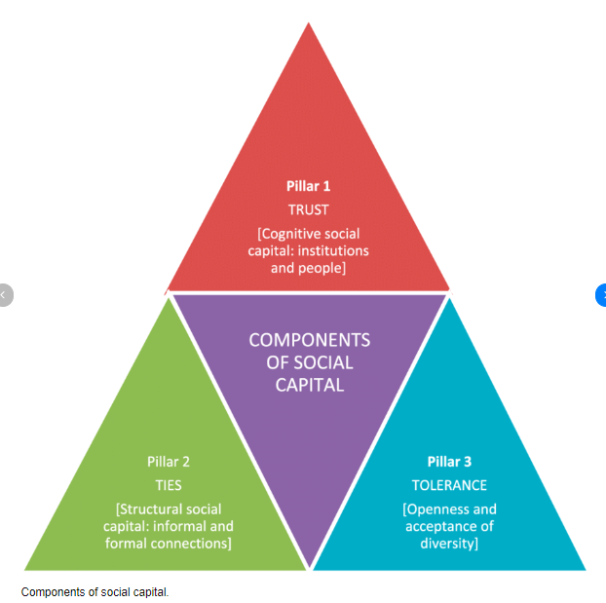
There are three components of social capital: networks (the interconnecting relationships between people), norms (the rules, values and expectancies that govern social interaction), and sanctions (the punishments and rewards that enforce the norms). These three components interact, influence and reinforce each other. For example, networks are shaped by norms, which are enforced by sanctions, which are expressed through networks. Thus, the components of social capital, though distinct, are interrelated and dependent upon each other.
There are also three levels of analysis for social capital: micro, meso and macro (though many social capital scholars only recognize the meso-level as social capital). At the micro-level, social capital consists of close ties to family and friends. Meso-level social capital refers to communities and associational organizations. Macro-level social capital consists of state and national-level connections such as common language and traffic customs.
Forms of Social Capital:
Social capital is often conceptualized in three main forms: bonding, bridging, and linking, each representing different types of relationships and social networks.
- Bonding Social Capital: This refers to the strong ties among individuals in close-knit groups, such as family, close friends, or people within a shared community. It is characterized by trust and mutual support, often providing emotional or practical resources. However, it can sometimes lead to exclusivity and limit exposure to new ideas or opportunities.
- Bridging Social Capital: This form arises from connections between different social groups or individuals from diverse backgrounds. These ties are typically weaker than bonding social capital but are crucial for accessing new information, resources, and opportunities outside one's immediate circle. Bridging social capital enhances inclusion and innovation by linking different social groups.
- Linking Social Capital: This refers to relationships between individuals and institutions or people in positions of power. These connections facilitate access to resources, information, and support that can come from formal organizations or systems of governance, making it especially relevant for social mobility and the distribution of resources in society.

Importance of Social Capital for Organizations:
Social capital plays a crucial role in organizational success. Here’s how it benefits organizations:
- Improved Collaboration and Teamwork:
Social capital fosters strong relationships between employees, encouraging better communication, trust, and collaboration.
Example: In companies with high social capital, employees are more likely to share knowledge freely, support each other in tasks, and collaborate effectively across departments, which enhances productivity and innovation.
- Enhanced Knowledge Sharing:
Employees with strong networks are more willing to share insights, best practices, and lessons learned, which can reduce redundancy and improve decision-making.
Example: In a technology firm, employees who maintain strong informal networks may share crucial technical knowledge that isn’t documented in official resources, helping teams solve problems faster and more creatively.
- Increased Employee Engagement and Retention:
When employees feel connected to their colleagues and the organization, they tend to be more engaged and loyal.
Example: An organization that promotes team-building activities, mentorship programs, and a culture of openness tends to have lower turnover rates, as employees feel valued and part of a community.
- Facilitates Innovation:
Bridging social capital between employees from different departments or even different organizations can bring in diverse perspectives, which often sparks new ideas.
Example: Cross-functional teams in organizations like Google or Apple leverage diverse networks to generate creative solutions, leading to innovative products and services.
- Improved Organizational Culture:
Social capital contributes to the development of a positive organizational culture where trust, respect, and mutual support prevail.
Example: Companies with high social capital often have a more inclusive, transparent, and positive work environment, where employees feel comfortable voicing ideas or concerns without fear of reprisal.
- Enhanced Organizational Resilience:
Strong internal networks help organizations better handle crises or changes, as employees are more likely to pull together and support one another during difficult times.
Example: In times of economic downturns or company restructuring, organizations with strong social capital experience better employee morale and cohesion, allowing them to navigate the challenges more smoothly.
- Faster Problem-Solving:
Employees with wide networks can reach out to different teams, departments, or external contacts for quick solutions to issues.
Example: In a multinational corporation, an employee might use their internal network to get critical information from a colleague in another country, speeding up problem resolution.
- Attracting and Retaining Talent:
Organizations with a reputation for strong social capital are more attractive to top talent, as employees prefer workplaces where collaboration, trust, and strong relationships are encouraged.
Example: Companies like Salesforce or Zappos, known for their strong corporate culture and social networks, often attract highly skilled professionals looking for a collaborative work environment.
- Building External Relationships and Partnerships:
Social capital extends beyond the organization’s internal networks to include relationships with external stakeholders, such as clients, suppliers, and partners, leading to strategic advantages.
Example: A startup may leverage its founder’s social capital to build partnerships with key investors, suppliers, or distributors, helping the company grow rapidly.
- Supports Organizational Learning:
Strong social networks within an organization facilitate continuous learning, as employees share insights from formal and informal experiences.
Example: Organizations with a culture of mentorship, peer learning, and open communication often see faster development of employee skills and capabilities, contributing to long-term success.
Social capital thus helps organizations function more efficiently by fostering trust, collaboration, and a shared sense of purpose. This not only improves performance and innovation but also helps organizations stay adaptable and resilient in the face of change.

Milton Friedman Theory
The Friedman Doctrine or Shareholder Theory, introduced by economist Milton Friedman in 1970, asserts that the primary responsibility of a business is to maximize profits for its shareholders. This idea has been central to business ethics, influencing corporate governance, management strategies, and economic policies for decades.

Key Aspects of the Friedman Doctrine:
- Maximizing Shareholder Value:
The fundamental principle is that a company’s only responsibility is to maximize returns for its shareholders. Business executives, as employees of shareholders, are expected to focus on profit-making.
- No Obligation to Social Responsibility:
Friedman argues that businesses do not have any inherent social responsibilities, except when shareholders decide otherwise. A company should not engage in social initiatives unless explicitly directed by its owners.
- Business as a Profit-Driven Entity:
The doctrine suggests that the primary goal of a business is economic efficiency. If companies focus on making profits, they contribute to the economy and society by creating jobs, paying taxes, and enabling economic growth.
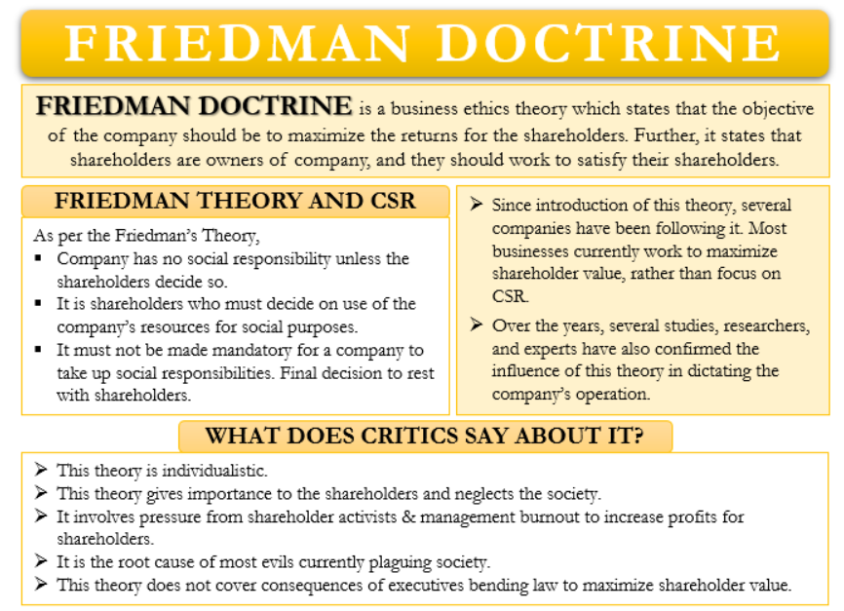

Friedman Doctrine and Social Responsibility:
Friedman contends that social responsibility, if imposed on a company, could lead to a misallocation of resources. Since such initiatives usually come with significant costs, they should only be pursued if shareholders deem it beneficial. Executives should focus solely on business activities that directly maximize shareholder profits.

Influence of the Friedman Doctrine:
The doctrine has deeply influenced corporate governance and business strategies since its introduction. Many companies have aligned their goals with maximizing shareholder value, resulting in profit-centric operations and decision-making.
For instance:
- Corporate Governance: Most businesses prioritize increasing profits and shareholder returns over corporate social responsibility (CSR) activities.
- Business School Education: The doctrine has been a foundational concept in business and management education, emphasizing that a company's purpose is to serve its shareholders.
- Wider Adoption: Large corporations and financial institutions have historically followed this profit-maximizing approach, focusing resources on strategies that directly benefit shareholders.
Criticism of the Friedman Doctrine:
Despite its widespread influence, the Friedman Doctrine has faced significant criticism:
- Neglect of Social Responsibility:
Critics argue that the doctrine dismisses the importance of community and stakeholders such as employees, customers, and the environment. A company’s long-term success is often linked to its social standing and goodwill within the community.
- Societal Impact:
The exclusive focus on maximizing shareholder value is seen by critics as contributing to various societal issues, including economic inequality, environmental degradation, and social unrest. The pressure to increase profits may drive companies to overlook broader societal impacts, such as climate change, worker exploitation, or ethical violations.
- Encouragement of Short-Termism:
Focusing solely on shareholder value can encourage short-term decision-making at the expense of long-term sustainability. For instance, companies may cut costs (e.g., layoffs, reduced environmental spending) to meet quarterly earnings targets, which could harm their long-term prospects.
- Encourages Legal Loopholes:
While the doctrine emphasizes that companies should operate within the law, there are numerous cases where companies or executives bend or exploit legal loopholes to maximize profits, often at the expense of broader societal welfare.
- Moral and Ethical Concerns:
Critics argue that companies have a moral responsibility to all stakeholders, not just shareholders. Ethical issues, such as worker rights, environmental protection, and equitable treatment of customers, are often neglected under this profit-maximizing philosophy.

Thomas Donaldson’s Ethical Algorithm:
Thomas Donaldson, a prominent figure in business ethics, developed the Ethical Algorithm as a decision-making tool to guide managers and business leaders when facing ethical dilemmas. It's particularly useful when the legal framework doesn’t offer clear guidance, or when an action might be legal but still ethically questionable.

Underlying Philosophy:
Donaldson’s algorithm integrates deontological (duty-based) ethics with practical reasoning. It moves beyond simple “profit vs. loss” and asks:
Is the decision right, not just effective?
Are we respecting the rights of individuals and communities?
How does this affect our moral integrity and corporate responsibility?

Theoretical Roots of the Algorithm
The Ethical Algorithm blends several ethical traditions:
1. Deontology (Kantian Ethics)
- Focus on duties, principles, and universal moral rules.
- Ask: “Would this be acceptable if everyone did it?”
2. Consequentialism (Utilitarianism)
- Focus on outcomes — greatest good for the greatest number.
- Ask: “Does this action minimize harm and maximize benefit?”
3. Virtue Ethics (Aristotle)
- Focus on moral character and integrity.
- Ask: “Does this action align with who we want to be?”
4. Social Contract Theory
- Focus on mutual agreements between stakeholders and society.
- Ask: “Would this be acceptable in a just and fair society?”
Donaldson’s algorithm brings these together to form a practical compass for real-world decision-making.
The Ethical Algorithm – Step-by-Step Analysis
1. Is the action consistent with the organization's and individual's core ethical values?
This step reflects internal integrity. Actions should align with values like honesty, fairness, and respect.
If the action violates core beliefs (like honesty, fairness, or responsibility), it signals value dissonance.
Example: A company that prides itself on transparency should not hide side-effects of a drug.
2. Is the action legal and compliant with regulatory standards?
Legal compliance is a minimum ethical standard — not the ceiling.
An action might be legal but still unethical (e.g., exploiting tax loopholes).
This step ensures you’re not breaking the law but warns you to look beyond legality.
3. Who are the stakeholders affected, and does the action cause unjust harm?
This introduces consequentialist thinking: Who gains, who loses, and is it fair?
Stakeholders include employees, customers, suppliers, communities, and the environment.
Harm is sometimes inevitable — but is it minimized, justified, or disproportionate?
4. Would I be comfortable if the decision were made public — e.g., reported in the media?
This is the "Sunlight Test" or Public Disclosure Test.
If you’d be ashamed to see your decision on the front page, it’s likely unethical.
This reinforces transparency, reputation, and accountability.

Practical Business Example:
Scenario: A company is considering outsourcing to a supplier known for low prices but with poor labor conditions.
Applying the Algorithm:
Is it aligned with our value of “ethical supply chains”? → ❌ No.
Is it legal? → ✅ Yes.
Are workers (stakeholders) being harmed? → ❌ Yes, poor labor conditions.
Would we want this published in the press? → ❌ No.
Conclusion: The company should avoid this supplier, despite the cost benefits.
VALUE BASED MARKETING
Values-based marketing happens when a brand connects with its audience based on shared values. It’s an outward-focused strategy fueled by authenticity and focused on doing good in the world. Beyond what a brand sells, values-based marketing seeks to resonate with its target audience on closely-held social and ethical issues. Value marketing is part of a customer-centric business strategy based on customers' needs. It appeals to your customers' wants and needs and focuses on connecting with them to build brand trust.
Instead of marketing your business by focusing on your company's greatness, you'll focus on your existing customers' wants and needs, providing data-backed evidence for how your product provides value. Simply put, a value-based marketing campaign can help you identify customer pain points and find ways to promote your product as a solution to their common problems. In addition, value-based marketing can help you find new ways to market your products and services to customers without constantly selling — something your customers don't want. Instead, they want to connect with brands on a more emotional level.
Ultimately, how do customers find value in your products or services? What value does it offer them? That's value-based marketing.
Quad of Quality, Service, and Price is a conceptual framework that helps businesses balance these three critical elements to meet customer expectations and deliver competitive value. It involves understanding how quality, service, and price interact to create value for the customer and achieve business success.

1. Quality
Definition:
Quality refers to the degree of excellence of a product or service, based on its ability to meet customer expectations, function as promised, and deliver satisfaction.
- High Quality: Products that perform reliably, have durable materials, and exceed customer expectations.
- Low Quality: Products that fail to meet basic performance standards, have defects, or deliver an unsatisfactory customer experience.
Impact on Value:
High-quality products justify higher prices and build customer loyalty, while low-quality products can tarnish brand reputation and lead to customer dissatisfaction.

2. Service
Definition:
Service refers to the customer experience surrounding the product, including aspects like customer support, delivery time, user-friendliness, and after-sales service.
- High Service: Offering great customer support, fast delivery, user-friendly experiences, and assistance throughout the customer journey.
- Low Service: Lack of customer support, slow response times, or poor user experiences.
Impact on Value:
Exceptional service can make customers feel valued and more likely to make repeat purchases, whereas poor service can lead to frustration and customer churn.

3. Price
Definition:
Price refers to the monetary cost of the product or service. It’s how much the customer is willing to pay for the perceived value, considering the product's quality and the service received.
- High Price: Products or services that are priced higher because of their superior quality, brand image, or exceptional service.
- Low Price: Products priced competitively or discounted to attract budget-conscious customers.
Impact on Value:
Price is a balancing act — setting it too high may limit market reach, while setting it too low could imply low quality or unsustainable business practices.

There are four types of value in marketing:
Functional: Functional value refers to the product and its use, such as the benefits to customers who use it.
Emotional: Emotional value is anything that makes your customers feel good when they use your product.
Economic: Economic is the cost of the product or services, with the value being the cost of your product versus the cost savings of using your product.
Social: Social value refers to whether your product helps individuals interact with others.

Key Components of Value-Based Marketing
Value-Based Marketing isn’t about pushing products — it’s about connecting deeply with customers, understanding their struggles, and showing how your brand adds real, lasting value to their lives or businesses.

1. Understand Customer Needs and Wants
Before you market anything, ask:
“What truly matters to my customer?”
This goes beyond demographics. It’s about tapping into motivations, desires, goals, and frustrations.

How to do it:
- Create detailed customer personas.
- Use data, surveys, and feedback to understand what customers care about.
- Focus on the benefits your product provides, not just its features.
📌 Example: If you're selling automation software, your audience isn’t just looking for tech — they want efficiency, time savings, and stress-free operations.

2. Identify Customer Pain Points
Customers buy solutions, not products. The most effective value-based marketing directly addresses a real problem they face.
Ask:
“What keeps my customer up at night?”
Then, position your product as the relief they’ve been looking for.
📌 Example: If productivity is a pain point, don’t just say “We improve productivity” — say,
“Our software helped companies like yours boost team efficiency by 25% — backed by case studies.”
✔ Back up claims with proof: data, testimonials, case studies.

3. Craft a Clear, Compelling Value Proposition
Your value proposition is your brand’s promise. It tells people what you offer, how it helps them, and why they should care — all in a sentence or two.
Ask:
“Why should someone choose us over anyone else?”
Make sure it’s:
- Specific (what value do they actually get?)
- Relevant (does it address their pain?)
- Authentic (can you really deliver it?)
Also create a USP (Unique Selling Proposition) — something that highlights why you’re different. But always tie it back to what benefits the customer.

📌 Example:
- USP: “Only our platform combines accounting, invoicing, and tax tools built just for solo entrepreneurs.”

4. Consistently Deliver Value
Your job doesn’t end when the sale is made. Value-based marketing continues after purchase — in how you support, guide, and engage your customers.
Ask:
“How can we keep helping the customer succeed?”
Ways to deliver value continuously:
- Educational content (blogs, videos, webinars)
- Post-purchase tips or tutorials
- Responsive customer support
- Feedback loops for improvements
📌 Example: Send new customers onboarding emails with productivity tips or invite them to exclusive webinars that help them get more from your product.

Importance of Value-Based Marketing
1. Builds Long-Term Customer Loyalty
When customers feel that a brand genuinely understands their needs and provides consistent value, they develop emotional loyalty. Unlike transactional loyalty (based on price or convenience), emotional loyalty leads to customers returning repeatedly, even if competitors offer discounts or newer features.
Example:
Apple customers often stay loyal for years because they perceive value in the brand experience, ecosystem integration, and customer service — not just the iPhone itself.

2. Strengthens Brand Reputation
Brands that align with meaningful values (e.g., sustainability, equality, innovation) are viewed as more ethical and credible. A strong reputation is a long-term asset that not only attracts customers but also partners, talent, and media attention.
Example:
Patagonia has built its reputation by actively promoting environmental causes and responsible business practices, making it a favorite among eco-conscious consumers.

3. Increases Customer Satisfaction
Value-based marketing emphasizes customer success over company success. By prioritizing how a product improves a customer’s life or solves a pain point, companies foster genuine satisfaction. Satisfied customers are more likely to give positive reviews and refer others.
Example:
Zoom didn't just promote its video conferencing tools during the pandemic — it promoted its value in keeping families and businesses connected. That emotional satisfaction built goodwill and trust.

4. Drives Better Business Results
When customers see long-term value, they are willing to pay premium prices, remain longer, and contribute to higher lifetime value. These customers also generate referrals, reducing customer acquisition costs.
Example:
Salesforce provides more than CRM tools — it offers business transformation. Clients who receive this ongoing value are willing to invest more in premium features and long-term contracts.

5. Supports Ethical and Sustainable Growth
Today’s customers want to support businesses that do more than make money — they want brands that make a difference. Value-based marketing allows companies to tie business objectives with social or environmental impact, creating a more sustainable growth model.
Example:
The Body Shop emphasizes fair trade ingredients and ethical sourcing. This not only draws socially-conscious customers but builds a purpose-driven internal culture.

6. Improves Customer Engagement
When customers see a brand sharing content or values they care about, they are more likely to interact, share, and participate. This leads to deeper conversations, brand loyalty, and community building.
Example:
Nike’s campaigns often focus on empowerment, social justice, and personal victory. These themes spark high engagement across digital platforms and turn customers into brand advocates.

7. Differentiates You in a Crowded Market
In markets where many products offer similar features, value-based messaging helps your brand stand out by emotionally connecting with customers. Rather than competing solely on price or specifications, you're offering meaning and impact.
Example:
Airbnb differentiates itself not just as a place to stay, but as a way to "belong anywhere" — focusing on experiences, local culture, and human connection, not just rentals.

✅ Conclusion:
Value-Based Marketing goes beyond selling products — it's about making a difference in people’s lives. It creates deep relationships, builds strong brands, and fosters sustainable business success in a world where consumers care as much about how and why they buy as they do about what they buy.

Ethical Implications of Value-Based Marketing:

1. Truthful Communication
Marketing messages must be accurate, honest, and transparent. Any attempt to exaggerate the benefits of a product or service can mislead customers and damage trust. Providing truthful information ensures customers can make informed decisions based on reality rather than false promises.
Example:
A company claiming their product "cures" a disease without scientific backing can mislead vulnerable consumers, which is not only unethical but potentially dangerous.

2. Respect for Consumer Autonomy
Value-based marketing should aim to empower consumers, not manipulate them. Ethical marketing respects the ability of consumers to make independent choices and avoids tactics that exploit emotional vulnerabilities. It should not pressure or coerce individuals into decisions that aren't in their best interest.
Example:
Using fear-based marketing to sell insurance by exaggerating the dangers of not purchasing it manipulates consumer emotions and undermines their ability to make rational decisions.

3. Transparency
Transparency involves being open about how products work, their limitations, pricing, and how customer data is used. Misleading customers by omitting crucial information can result in distrust and legal consequences. Transparency builds long-term relationships based on trust and mutual respect.
Example:
A subscription service that advertises "free trials" but later charges undisclosed fees or makes it difficult to cancel the service is practicing unethical marketing by hiding essential details.

4. Authenticity in Messaging
For value-based marketing to be ethical, the brand's messaging must reflect its actual values and business practices. If a company promotes itself as socially responsible but engages in environmentally damaging practices, it’s seen as inauthentic or even hypocritical. Ethical marketing aligns its values with actions.
Example:
A brand that markets itself as eco-friendly but uses unsustainable materials in its products is being inauthentic, which undermines both customer trust and brand credibility.

5. Commitment to Deliver Promised Value
Value-based marketing emphasizes delivering on the promises made in marketing campaigns. If the company fails to meet customer expectations, it leads to dissatisfaction and reputational damage. Brands must ensure they can deliver the promised value and must not mislead customers by promising more than they can offer.
Example:
If a company promotes a product as "life-changing" or "revolutionary" and the product does not live up to those claims, customers feel deceived, which harms the company’s reputation.

6. Social Responsibility
Brands that embrace social responsibility integrate values such as fairness, sustainability, and inclusivity into their marketing efforts. Ethical value-based marketing focuses on promoting not only profits but also societal well-being. It’s about supporting causes that promote equality and environmental sustainability.
Example:
Brands like Ben & Jerry's actively support social causes and ethical practices, aligning their marketing with values such as environmental sustainability, fair trade, and social justice.

7. Ethical Use of Customer Data
Explanation:
Value-based marketing often relies on customer data for personalized experiences. However, ethical marketers should ensure data privacy and transparency in how customer data is collected, used, and shared. Misusing customer data or using it without consent undermines trust and violates ethical standards.
Example:
A company that uses customer data for targeted advertising without clear consent or transparency, or sells personal data to third parties without customer knowledge, is engaging in unethical behavior.

Conclusion:
Value-based marketing has the power to build trust, loyalty, and long-term relationships with consumers. However, it must be executed with high ethical standards to ensure that businesses are transparent, authentic, and respectful of consumer autonomy. Ethical value-based marketing goes beyond just profits — it contributes to building a sustainable, socially responsible, and trustworthy brand.

